A000-Mali-Dogon-Wedding Party-Bronze-19th c

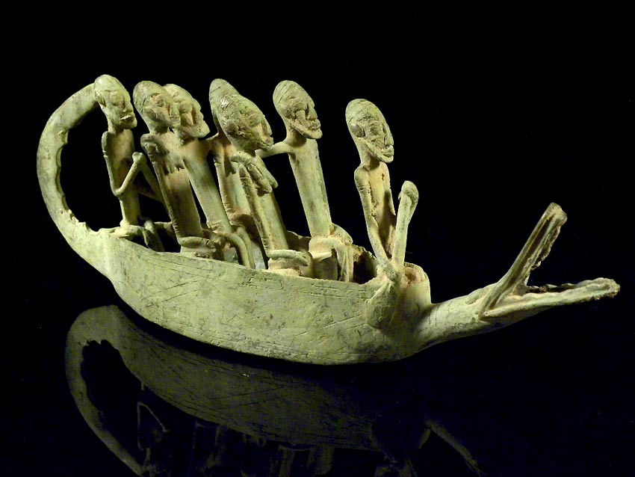

Dogon wedding party on a crocodile prowed pirogue.

**Case no.:**

**Accession Number:**

**Formal Label:**

**Display Description:**

* The benevolent crocodile totem
* Protects dual wedding couples
* On their honeymoon journey
* On the Cosmic River.
* Another example of Dogon cosmic ambiguity.
* **There are still some Dogon communities that claim *Nommo* as their ancestor, and call him *Binu*.**
* **The ancient Dogon myth of the world before the appearance of death:**
* **When elders were becoming too old, they would change themselves into a large water being, like a crocodile, and dwell in ponds and rivers,**
* **They would then begin a new life as a water spirit called *Nommo*, helping maintain the source of water for their descendants.**
* **These water spirits (*Nommo*) were, in fact, considered to be the ancestors of the autochthonous people still living in the Bandiagara Escarpment and were called "Binu" as a personal, familial nick-name, because they were, in fact, ancestors of the family.**

**LC Classification:**

**Date or Time Horizon:**

**Geographical Area:**

**Map:**

**GPS coordinates:**

**Cultural Affiliation:**

**Media:**

**Dimensions:**

**Weight:**

**Condition:**

**Provenance:**

**Discussion:**

**References:**

* The benevolent crocodile totem
* Protects dual wedding couples
* On their honeymoon journey
* On the Cosmic River.
* Another example of Dogon cosmic ambiguity.
* Griaule, Marcel. 1948. *Dieu de l'eau.* Paris: Fayard.
* Bouju, Jacky. 2003. The spirit of water: in the Dogon world, *Leonardo* (MIT Press)*,* 36(4): 279-280.